**ANTI THEFT FLOORING SYSTEM USING ARDUINO UNO AND PIEZOSENSORS**

N.Duraimurugan 1, Hayagriv Koushik.S 2, Hirthik Mathesh.GV 3

Associate Professor, Department of Computer Science and Engineering, UG Scholar, Department of Computer Science and Engineering

[duraimurugan.n@rajalakshmi.edu.in](mailto:duraimurugan.n@rajalakshmi.edu.in) 1, [210701081@rajalakshmi.edu.in](mailto:210701081@rajalakshmi.edu.in) 2, [210701084@rajalakshmi.edu.in](mailto:210701084@rajalakshmi.edu.in) 3

**ABSTRACT**

The rise of theft and unauthorized access in various settings has necessitated the development of advanced security measures. This abstract introduces an innovative Anti-Theft Flooring System (ATFS) designed to enhance security using Arduino Uno microcontrollers and piezoelectric sensors. The proposed system aims to detect and deter unauthorized access by sensing pressure changes on the floor surface, typically caused by human footsteps. Integrating Arduino Uno microcontrollers with piezoelectric sensors enables real-time data processing and immediate response actions. Upon detecting suspicious pressure patterns, the system triggers predefined security protocols, such as sounding alarms, activating CCTV cameras, or notifying security personnel. This abstract outlines the conceptual framework, design principles, and operational mechanisms of the ATFS. Additionally, it highlights the system's potential applications in various environments, including homes, offices, retail stores, and public spaces. The ATFS represents a significant advancement in proactive security solutions, offering reliable detection capabilities and prompt response actions to mitigate theft and unauthorized access incidents.

I. Introduction

In an age where security concerns loom large, innovative solutions are crucial for safeguarding properties and assets against theft and unauthorized access. One such pioneering approach is the Anti-Theft Flooring System (ATFS), which leverages the power of Arduino Uno microcontrollers and piezoelectric sensors to create a robust security infrastructure. This introduction sets the stage for exploring the intricacies and significance of ATFS in modern security applications.

Theft and unauthorized access pose significant challenges across various environments, ranging from residential spaces to commercial establishments. Traditional security measures such as locks and alarms offer some degree of protection, but they often fall short in providing real-time detection and response capabilities. Recognizing this gap, researchers and engineers have turned to cutting-edge technologies to develop proactive solutions that can preempt security breaches effectively.

The ATFS represents a paradigm shift in security systems by utilizing Arduino Uno microcontrollers, renowned for their versatility and programmability, in tandem with piezoelectric sensors. These sensors, capable of detecting pressure variations on surfaces, serve as the primary detection mechanism of the system. By strategically embedding these sensors within the flooring infrastructure, the ATFS can discern the subtle pressure changes induced by human footsteps, distinguishing between normal foot traffic and unauthorized access attempts.

The fusion of Arduino Uno microcontrollers and piezoelectric sensors empowers the ATFS with advanced functionalities. Real-time data processing capabilities enable the system to analyze incoming sensor data swiftly, facilitating immediate response actions when suspicious activity is detected. Moreover, the modular nature of Arduino Uno allows for seamless integration with other security peripherals, such as alarms, cameras, and notification systems, amplifying the system's effectiveness in deterring theft and unauthorized entry.

II. Literature Survey

1. IOT Based Anti-Theft Security System

The purpose of this project is to design a system which will protect our house or any place from thief in our absence by using a camera module operated by Arduino. This system mainly consists of a Web camera to detect guests, Arduino, Wi-Fi module, sensors, servo motor, resistor, ESP32 and a Mobile device for interfacing with the system. Whenever someone is entering in the house, immediately their movement will be sensed by the sensor which passes on the signal to Arduino controller. If the controller finds the request as valid after processing, then it turn on the camera which is linked to the controller to the area where the motion was detected and then sends it to the user over the Internet to check the footage. Sensors are linked to the Arduino processing unit. An input signal is generated by the sensors when they detect the motion. Once input signal is generated it will be transmitted to Arduino unit and it validates the request. Camera linked to the Arduino will capture the video based on the input signal. Video frames which are collected by the camera are transmitted to the owner over the internet using Wi-Fi module. The owner in turn can take the required action in order to protect his/her house or shop from robber.

2. IOT Based Anti-Theft Flooring Mat-System Using Arduino Uno

In today’s world, security has become the most challenging task. With the rapid urbanization and development of big cities and towns, the graph of the crime is also on the rise. IoT based anti-theft flooring mat-system using Arduino uno that use sensor on walls on motion detections. The IoT allows objects to be sensed and controlled remotely across exciting network infrastructures, creating opportunities for more direct integration between physical world and computer system resulting in improved efficiency, accuracy and economic benefit. To secure and guard our area in our absence, we purpose the IOT based anti-theft flooring system using Arduino uno. This system monitors the entire area for movement. One single step anywhere on the area is tracked and user is alarmed over IOT. In this system, secure flooring tile connected with IoT, when system is to be turn on, then whoever the comes inside the area it passes the information over IoT. Whenever the thief enters in the area, and step on the floor immediately it is sensed by the sensor which passes on the signal to Arduino uno controller. The controller in turn processes it to be valid signal and then moves the camera to the area where movement was detected and transmit it over the internet for the owner to check the image.

3. IOT Based Anti-Theft Flooring Mat-System Using Raspberry Pie

In today’s world, security has become the most challenging task. With the rapid urbanization and development of big cities and towns, the graph of crime is also on the rise. IoT-based anti-theft flooring mat system using Raspberry Pi that uses sensors on walls for motion detection. The IoT allows objects to be sensed and controlled remotely across exciting network infrastructures, creating opportunities for more direct integration between the physical world and computer systems resulting in improved efficiency, accuracy, and economic benefit. To secure and guard our area in our absence, we propose the IOT-based anti-theft flooring system using Raspberry Pi. This system monitors the entire area for movement. One single step anywhere in the area is tracked and the user is alarmed over IOT. In this system, secure flooring tile is connected with IoT, when the system is to be turned on, then whoever comes inside the area passes the information over to IoT. Whenever the thief enters the area, and steps on the floor immediately it is sensed by the sensor which passes on the signal to the Raspberry Pi controller. The controller in turn processes it to be a valid signal and then moves the camera to the area where movement was detected and transmits it over the internet for the owner to check the image. Keywords: IoT (Internet Of Things), Raspberry Pi, Piezo Sensor, Camera, USB, Buzzer, Alarm, Alert

4. Enhancing Home Security with Pressure Mat Sensors: A Multi-modal IoT Approach

Home security is a major concern worldwide, and there are various solutions available, but with limitations. This paper proposes a novel security system that overcomes the limitations of current systems by using piezoresistive sensors placed inside a mat to detect intruders with varying levels of pressure intensities. The proposed system incorporates a camera and a CNN algorithm with the Efficient Net model to detect whether the object is a human, and it is equipped with features like an email and SMS notification mechanism, backup battery, and a sophisticated tracking mechanism. The proposed system is highly resilient to tampering or circumvention and outperforms existing security systems in terms of being non-intrusive, providing tracking features for the intruder, and being resistant to blackouts. This paper documents the research, development, testing, evaluation process, and contributions made to address the security challenges by developing an affordable, easy-to-use, and effective home security system.

5. Theft alarm system using Arduino Uno’s PIR motion and tilt ball switch sensors

This applied experimental research aimed to enhance a theft alarm system that will be installed in the doors, cabinets, and lockers of homes and buildings to promote security and nurture a safer and thief-free community by combining PIR motion and Tilt Ball Switch sensors into a single device. Descriptive statistical methods were used to evaluate the level of effectiveness of the alarm system in terms of distance from the source and type of place, as well as the level of efficiency of the product utilizing the GSM module and sim card. The researchers also used the linear regression model to characterize the relationship between the speed of other living organisms entering the vicinity of the PIR motion sensor and the theft alarm system detection time. The study's findings revealed that the level of effectiveness of the theft alarm system depends on how close an individual is to the source, the theft alarm system has a very high level of effectiveness in terms of any type of place, there is a high level of production efficiency using the GSM module and sim card in the theft alarm system, there is a significant difference in the level of effectiveness of the theft alarm system in detecting the motion of individuals in terms of the distance from the source, and the detection capability of the PIR motion sensor is affected by the speed of organisms within its vicinity. The researchers recommend considering using other types of sensors or technologies that may be better suited to detecting organisms moving at high speeds.

6. IoT Based Anti-Theft Detection and Alarm System Using Node MCU and Blynk Application

The purpose of building this system is to prevent the loss of property due to theft that we face in our daily lives. This system includes NodeMCU with Esp8266 Wi-Fi module based on microcontroller, PIR sensor to use the motion detection, ultrasonic sensor to know the distance from the obstacles, buzzer to use the alarm system, Blynk application to use the reporting message and light bulb to illuminate around the environments. When sensor detected the movement of objects, sends a message to phone, lights up the bulb, and then alert alarm because Esp8226 Wi-Fi module is connected to Blynk application. The problems found with existing systems were that they can only identify the intruder after the theft, or cannot distinguish between human and non-human objects. So, this system will be essential for every building because it is not just easy to use but is also inexpensive.

7. IOT Based Anti-Theft Flooring System

Most of the crimes occurs in big shops, jewelry shops, houses etc. all these places are implemented with a CCTV camera only and no any other security is provided to that shops. in that case most of the crimes are held and owners of that shops have to suffer from a big loss and the police catch those criminals after so many days or after many months or we can say crimes are usually found out after it is being committed. Crime rate is also increasing very rapidly and after looking all this I have decided to make smart monitoring system that is IOT based anti-theft flooring system. The main objective is to make this it will detect crime or any unnecessary actions that are performed and required actions will be taken at instant only. So that owners don’t have to worry about their assets and their assets will be safe from stealing. It captures an image when any motion is detected is prevented in secured areas.

8. IoT Based Anti-Theft System

A security system involves the detection of intrusion, trespassing, or unauthorized entry into a home or any protected area and getting alarmed of such unauthorized access to protect assets and people from being damaged or harmed. Since the emerging of modern technology, commercial, industrial, and military properties have been extensively using some sort of security system for safeguarding against theft, property damage, or personal harm In recent years, the importance and demand for home security systems have been noticeably rising as well, especially in urban areas. Since nowadays, people are increasingly keeping them out of home for works and other purposes, houses are becoming victims of burglary by means of illegal entry by force, such as breaking a glass-window or slashing a glass-door or by entering through an unlocked door or an open window. Studies have pointed out that burglaries and intrusion-related crimes occur extremely less in places where a home security system is installed. Not very long ago, home security systems or monitoring cannot be accomplished without human maneuver. Even today, security guards and trained-up dogs are common practice to tackle the issue, since it is evident that the crime is not going away from our society completely. Besides, people are remaining outside more than ever today, leaving their homes vulnerable if proper measures are not taken. While human security guards and trained-up dogs are reliable to a certain degree, but maintaining them is always costly and they can be fooled and corrupted. To address these issues, and to keep up with the rapidly evolving technology, the home security system needs to be automated with minimum human intervention to keep it safe, no matter if the home is occupied or empty. The concept of automated home security systems has been around since the 1970s. But with the progress and expansion of technology, both our expectations and the idea of home security systems have been shifted. Home security systems involve some critical parameters like gas leakage system, fire/smoke alarming system, theft, and intruders monitoring system, etc. Many sophisticated techniques and systems are now available to serve the purpose. The latest programmable devices, controllers, sensors, video cameras, and loud buzzers are used to address the issue. Recently, very comprehensive and error-free systems are available, which are both accurate and cost-effective. Many alarm monitoring services of today’s home security system now allow users to access their system via the Internet. Users can check the system status remotely, and even view real-time video feed if CCTV cameras are installed. Today’s systems even allow users to change their security passwords, lockout the security passwords, and arm or disarm the security system via the Internet. However, the trend of low cost and low power Microcontroller based home security system automation is not yet faded, rather still emerging. Hence, the work in this paper is focused on the very area. Any system or device that is required to measure, store, control, calculate, or display information is an appropriate candidate for using a microcontroller in it. A microcontroller is a small electronic device that can be considered as a single-chip and special-purpose computing machine dedicated to repetitively accomplishing a specific task. Similar to a general-purpose computer, a microcontroller comprises CPU core, memory units (RAM, ROM, Flash), and I/O ports Since the device is very small, and it is designed to control objects, processes, or events; hence the name microcontroller.

III. Limitations In Existing System

The Anti-theft flooring system can be effective in some scenarios, it also has several limitations such as:

* False Alarms
* Vulnerability to Tampering
* Limited Integration with Other Systems
* Dependency on Power Sources
* Complex Installation and Maintenance
* Limited Scalability
* Cost
* Power Requirements

Limited Detection Range: Traditional anti-theft systems often rely on sensors placed in specific locations, such as doors or windows. This limited coverage can leave blind spots where intruders may go undetected, especially if they gain access through unconventional means like walls or ceilings.

False Alarms: Many existing systems are prone to triggering false alarms, leading to unnecessary disruptions and desensitization of security personnel. Factors such as environmental conditions (e.g., wind causing movement of objects) or technical malfunctions can contribute to false positives, undermining the system's reliability.

Vulnerability to Tampering: Conventional security measures, such as locks and alarms, can be circumvented by determined intruders through various means, including lock picking, jamming signals, or disabling sensors. This vulnerability compromises the effectiveness of the system and undermines its credibility as a deterrent.

Limited Integration with Other Systems: Incompatibility issues often arise when attempting to integrate different security components from various manufacturers. This lack of interoperability hampers the seamless operation of the overall security infrastructure, limiting its effectiveness in responding to security threats comprehensively.

Dependency on Power Sources: Many existing anti-theft systems rely heavily on external power sources, such as electricity or batteries. Power outages or drained batteries can render these systems inactive, leaving properties vulnerable during critical moments.

Complex Installation and Maintenance: Installing and maintaining traditional anti-theft systems can be cumbersome and costly, requiring professional expertise and periodic servicing. This complexity increases the barrier to adoption, particularly for small businesses or homeowners with limited resources.

Limited Scalability: Scalability is often a challenge with existing systems, especially when expanding coverage to larger areas or integrating additional security features. The lack of flexibility in adapting to evolving security needs can hinder the long-term viability of the system.

Cost: Depending on the scale and complexity of the installation, the cost of implementing the system can be significant. This might be prohibitive for some individuals or businesses, especially considering the potential limitations mentioned above.

Power Requirements: The system would require a power source to operate continuously. Depending on the installation location, providing a reliable power source may pose challenges or additional costs.

Addressing these limitations is essential for advancing the effectiveness of anti-theft systems and ensuring comprehensive protection against security threats. The integration of emerging technologies, such as IoT (Internet of Things) devices, artificial intelligence, and advanced sensor technologies, holds promise for overcoming these challenges and ushering in a new era of proactive and adaptive security solutions.

IV. Proposed System

The anti-theft flooring system utilizing Arduino Uno and piezoelectric sensors operates through a combination of sensor monitoring, threshold detection, and alarm triggering mechanisms. Once the system is initialized upon power-up, the Arduino Uno continuously monitors the signals from piezoelectric sensors embedded strategically beneath the flooring surface. These sensors react to pressure or vibration, such as footsteps, and generate corresponding analog signals. The Arduino compares these signals to a predefined threshold level set to distinguish between normal activity and potential intrusion attempts.

When the sensor readings surpass the established threshold, indicating a significant pressure or vibration, the Arduino interprets this as a potential intrusion and proceeds to trigger the alarm system. The alarm system, which could comprise audible alerts, visual indicators, or wireless notifications to connected devices, is promptly activated to alert nearby individuals or security personnel of the unauthorized activity. This activation prompts a response from those monitoring the system, who may then investigate the area, contact authorities, or implement appropriate security measures to thwart the attempted theft or intrusion.

Following the triggering of the alarm, the system may incorporate a reset mechanism to silence the alarm once the threat has been addressed. This reset functionality can be achieved through manual intervention, such as pressing a reset button, or automatically after a predetermined duration. Additionally, the system may include logging and reporting features to record intrusion events, including timestamps, sensor readings, and any actions taken in response. Regular maintenance and monitoring are crucial to ensure the system's proper functioning, involving checks for sensor integrity, verification of alarm responsiveness, and timely replacement of any malfunctioning components. Overall, the anti-theft flooring system serves as a proactive security measure, effectively detecting unauthorized access and facilitating timely responses to mitigate the risk of theft or intrusion.

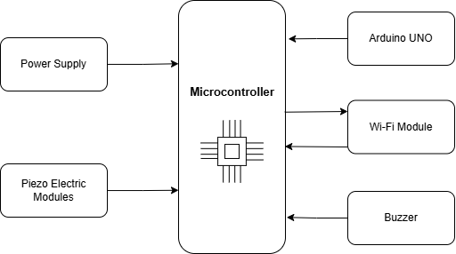

***Figure 1: System Architecture***

The anti-theft flooring system uses an Arduino Uno and piezoelectric sensors to detect pressure or vibration caused by footsteps or movement. The Arduino Uno acts as the central processing unit, continuously monitoring the analog signals from the sensors and processing the incoming data using programmed algorithms. A threshold detection algorithm is implemented within the Arduino Uno to determine when sensor readings indicate potential intrusion. If the sensor readings exceed a predefined threshold level, an alarm is triggered.  
  
The alarm system is activated when the threshold detection algorithm identifies a potential intrusion and can consist of various components such as Audible Alarms, Visual Indicators, and Wireless Communication Modules. A stable power source is required for continuous operation, which can be provided through mains power or battery backup depending on installation requirements.  
  
Optional components include a Wireless Communication Module for remote monitoring and control, and Data Logging and Reporting for additional functionality to log intrusion events, store data, and generate reports for later analysis.  
  
In summary, the anti-theft flooring system combines piezoelectric sensors, Arduino Uno, threshold detection algorithms, alarm systems, and power supply components to create a robust security solution.

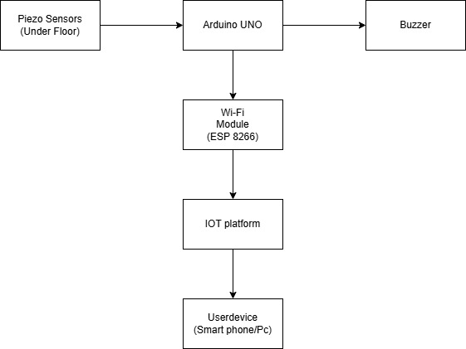

V. Work Process

1. Object Detection

The Arduino Uno is used in an anti-theft flooring system to detect potential intrusions in real-time. Sensor readings are taken from pressure sensors embedded within the flooring material, which detect changes in pressure when someone steps on or applies force. Analog readings are then connected to analog pins of the Arduino Uno, allowing the Arduino to detect the level of pressure applied to each sensor. A threshold value is set based on the sensors' sensitivity and the desired trigger point for the alarm. When the analog reading exceeds this threshold, the Arduino triggers a buzzer to sound, alerting the system operator or occupants. The buzzer is then connected to a digital pin of the Arduino, which sends a signal to the buzzer to activate the alarm. The code typically includes a delay or timer to control the buzzer's sound duration. The system may also reset the buzzer after a certain period to prevent continuous alarm activation.

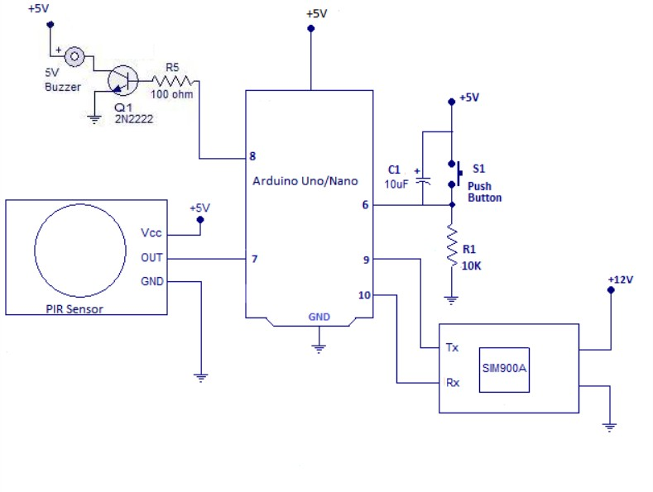

Tx wifi Module

2. Range and Sensitivity

To determine the range and sensitivity of a pressure sensor in an anti-theft flooring system using Arduino Uno, follow these steps:  
  
Check the sensor specifications by referring to the datasheet or product specifications. This includes the operating range, sensitivity, resolution, and output type.  
  
Set up the pressure sensor with the Arduino Uno according to the manufacturer's instructions. Write an Arduino sketch to read and print analog values as pressure is applied. Observe the readings and determine the effective range of pressure values the sensor can reliably detect. Adjust the sensitivity if necessary, and test the sensor's response to subtle changes in pressure.  
  
Fine-tune the threshold value in the Arduino code based on the sensor's sensitivity and the desired trigger point for the alarm.  
Conduct iterative testing and adjustments based on real-world performance and feedback. By carefully evaluating the pressure sensor specifications and conducting thorough calibration and testing, you can determine the required range and sensitivity for your anti-theft flooring system using Arduino Uno and the buzzer output.

3. False Alarming

To minimize false alarms in an anti-theft flooring system using Arduino Uno and a buzzer, consider the following techniques:  
  
Set the threshold for triggering the alarm cautiously, ensuring it is sensitive enough to detect genuine intrusions but not so sensitive that it triggers false alarms due to minor disturbances. Experiment with different threshold levels during testing to find the optimal balance.  
  
Implement filtering and signal processing techniques in your Arduino code to smooth out sensor readings and remove noise. A delay mechanism in your code can be introduced to require sustained pressure on the sensors before triggering the alarm.  
  
Calibrate the sensors carefully to ensure they are responsive to genuine intrusion events while minimizing false alarms. This may involve adjusting sensor sensitivity, addressing environmental factors, and optimizing sensor placement.  
  
Consider environmental factors that could impact sensor readings, such as temperature fluctuations, humidity, and external vibrations. Shield the sensors from direct sunlight or drafts.  
  
Conduct thorough testing and validation to validate the reliability of your system and identify potential sources of false alarms. Incorporate feedback mechanisms to alert users when a false alarm occurs, allowing them to confirm or reset the system if triggered erroneously.

4. Distance Between The Object And The Pressure Sensor

The distance between an object and a pressure sensor can be estimated using a general approach. This involves calibration, force to pressure conversion, pressure distribution, and distance estimation. Calibration involves applying known forces to the sensor and measuring the corresponding pressure readings. Force to pressure conversion converts the force exerted by the object on the sensor to pressure, depending on the sensor's characteristics. Pressure distribution considers the distribution of pressure exerted by the object on the sensor surface. Estimating distance involves calculating the force diminishing with distance from the object, which may involve mathematical models or empirical observations. Validation and adjustment involve testing the distance estimation method under various conditions and comparing results against known distances or measurements obtained using other methods. While pressure measurements may have limitations compared to dedicated distance sensors, with careful calibration and analysis, you can still derive useful distance estimates from pressure sensor data for certain applications.

VI. Execution

The anti-theft flooring system uses pressure detection and signal processing to detect potential unauthorized entry. Piezoelectric sensors under the floor mat generate voltage signals when someone steps on them. The Arduino Uno reads these signals and interprets them as potential intrusions. An alert is activated when an intrusion is detected, and the Arduino communicates with a Wi-Fi module to transmit data. The Wi-Fi module sends intrusion data to the Blynk IoT platform, which processes it and sends real-time notifications to the user's device. The user receives an immediate alert, enabling prompt response to potential security breaches.

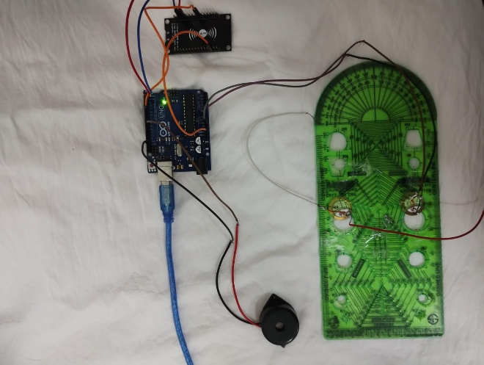

VII. Future Enhancements

The Arduino Uno and buzzer can be used to enhance an anti-theft flooring system, providing versatility, functionality, and reliability. Future enhancements include remote monitoring and control via IoT, camera integration, multiple sensor types, smart algorithms, biometric recognition, emergency notification systems, battery backup, tamper detection, integration with home automation systems, enhanced user interface, customizable alert settings, and environmental monitoring.  
  
Remote monitoring and control can be achieved through a smartphone app or web interface, allowing users to receive real-time alerts, arm/disarm the system remotely, and access historical data/logs. Camera integration can enhance security by providing visual confirmation of intrusions. Combining pressure sensors with other sensor types can improve detection accuracy and reduce false alarms.  
  
Smart algorithms for anomaly detection and pattern recognition can be developed using machine learning techniques to learn and adapt to changing environments. Biometric recognition can be integrated for user authentication, allowing authorized individuals to bypass the alarm system. Emergency notification systems can be included for automatic notifications to designated contacts or authorities in case of a confirmed intrusion.  
  
Battery backup systems can ensure the system remains operational during power outages, while tamper detection mechanisms can alert users if the system is tampered with or compromised. Integration with home automation systems can provide centralized control and seamless interaction with other smart devices.  
  
Enhanced user interfaces, customizable alert settings, and environmental monitoring can enhance the security, flexibility, and peace of mind for users.

VIII. Results And Discussions

The anti-theft flooring system was developed and tested using piezoelectric sensors to detect pressure changes under various flooring materials. The Arduino Uno accurately processed the sensor data, and a predefined threshold was established for distinguishing between normal and unauthorized movements. A buzzer connected to the Arduino produced an audible alert when the threshold was exceeded. The Wi-Fi module (ESP8266) facilitated seamless internet connectivity, allowing real-time notifications to be sent to the IoT platform. The IoT platform, Blynk, was chosen for its user-friendly interface and robust notification system, enabling property owners to receive real-time alerts on their smartphones.  
  
However, challenges were encountered during testing, such as false positives and potential environmental factors affecting the Wi-Fi connection range and reliability. Fine-tuning the pressure threshold and incorporating additional logic to filter out false alarms could mitigate these issues. The anti-theft flooring system demonstrated its effectiveness and potential as an innovative security solution. Future improvements could focus on enhancing sensor accuracy, reducing false alarms, and ensuring robust network connectivity to increase the system's reliability and user satisfaction.

IX. Conclusion

The anti-theft flooring system, using piezoelectric sensors, an Arduino Uno, a Wi-Fi module, and a buzzer, effectively detects unauthorized pressure changes, triggers local alerts, and sends real-time notifications via the IoT platform, enhancing security in residential and commercial properties. Despite minor issues with false positives and Wi-Fi connectivity, the system's overall performance was satisfactory. Future enhancements could focus on sensor sensitivity, false alarm filtering, and network performance. This project showcases the potential for innovative, cost-effective security solutions.

References

Journal, I. (2020, December 14). *IRJET - IoT based Anti Theft Detection and Alerting System using Raspberry Pi*. SlideShare. https://www.slideshare.net/slideshow/irjet-iot-based-anti-theft-detection-and-alerting-system-using-raspberry-pi/240102060